Bahria University Karachi Campus

CALD – Project-Based Assignment
Instructor : Engr. Ramsha Mashood
Department of Software Engineering

Project Title:
Parking Slot Availability Indicator Using Sensor Inputs & Encoders

Muhammad Waleed | 02-131242-119
Submitted By:

Section: BSE 3B
Date of Submission: 13/12/2025

Introduction
With the rapid increase in vehicles efficient parking management has become essential. This project presents an automatic parking slot availability indicator implemented using combinational logic circuits. The system is designed to operate in two modes normal automatic parking and priority based automatic parking providing flexibility and improved parking guidance.
System Description
The system has four parking slots and each slot is monitored using an SPDT switch that works like a sensor. And a probe that work as an led. When a slot is occupied the switch gives a logic high and when the slot is empty it gives a logic low.
In the normal automatic parking mode logic gates are used to show the status of all parking slots at the same time. The system also gives an AnyEmpty indication when at least one slot is available and turns on a Full indicator when all parking slots are occupied.
In the priority based automatic parking mode logic gates such as AND, OR and NOT are used to apply priority logic. In this mode the system highlights only the first empty parking slot based on a fixed priority order. The result is shown using led indicators making it easy for the driver to see which slot is available first.
Inputs & Outputs
Inputs:
- Slot 1 Sensor (Key A)
- Slot 2 Sensor (Key B)
- Slot 3 Sensor (Key C)
- Slot 4 Sensor (Key D)
Outputs:
- Green Indicator: Slot Empty
- Red Indicator: Slot Occupied
- AnyEmpty Indicator
- Full Indicator
Boolean Expressions & Simplification

Non Priority Automatic Parking Slot Indicator:

AnyEmpty:
$$AnyEmpty=A'+B'+C'+D'$$
After Using demorgan’s Law:
$$AnyEmpty=(A⋅B⋅C⋅D)'$$

Full:
$$Full=A⋅B⋅C⋅D$$

Encoder Logic:
$$GREEN = A' + B' + C' + D'$$

$$RED = A + B + C + D$$

After Using Demorgan’s Law:
$$GREEN =(A⋅ B⋅ C⋅ D)'$$

$$RED =(A '⋅ B^{'}⋅ C^{'}⋅ D^{'})$$

Priority Automatic Parking Slot Indicator:

AnyEmpty:
$$AnyEmpty=A'+B'+C'+D'$$
After Using demorgan’s Law:

$$AnyEmpty=(A⋅B⋅C⋅D)'$$

Full:
$$Full=A⋅B⋅C⋅D$$

Encoder Logic:
$$G1=A' \\ G2=A⋅B' \\ G3=A⋅B⋅C' \\ G4=A⋅B⋅C⋅D' \\ G=A'+(A·B')+(A·B·C')+(A·B·C·D')$$
$$R1=A \\ R2=A'⋅B \\ R3=A'⋅B'⋅C \\ R4=A'· B'· C'· D \\ R=A+(A'·B)+(A'·B'·C)+(A'·B'·C'·D)$$

This Sop equation can not be reduced because It is already minimal if we reduce this equation further it destroys the priority behavior of the encoder.

Circuit Diagram
The circuit was designed using AND, OR, and NOT gates in Multisim. Each slot indicator and output signal is properly connected and verified using probes.
Non Priority Automatic Parking Slot Indicator:
Empty:
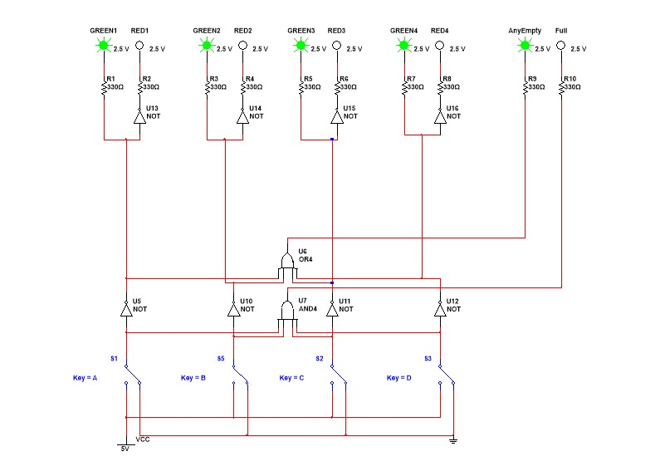
Full:
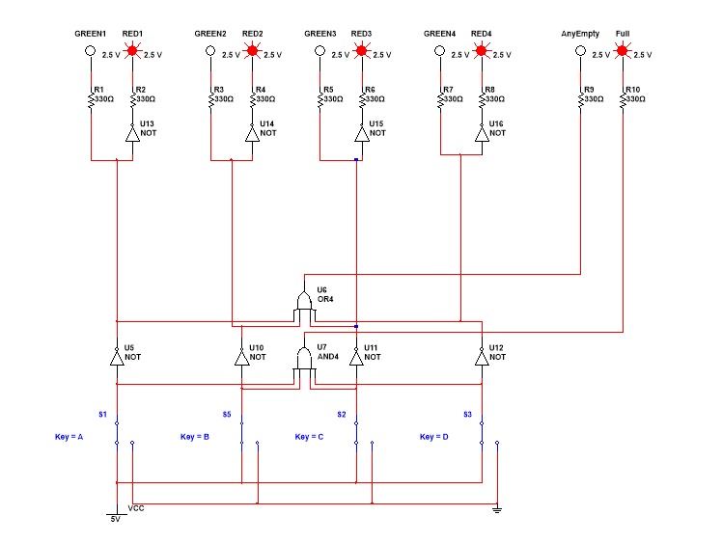
Non Priority Parking Slot Truth Table
Slot1 | Slot2 | Slot3 | Slot4 | Green1 | Green2 | Green3 | Green4 | Red1 | Red2 | Red3 | Red4 | AnyEmpty | Full
0 | 0 | 0 | 0 | 1 | 1 | 1 | 1 | 0 | 0 | 0 | 0 | 1 | 0
0 | 0 | 0 | 1 | 1 | 1 | 1 | 0 | 0 | 0 | 0 | 1 | 1 | 0
0 | 0 | 1 | 0 | 1 | 1 | 0 | 1 | 0 | 0 | 1 | 0 | 1 | 0
0 | 0 | 1 | 1 | 1 | 1 | 0 | 0 | 0 | 0 | 1 | 1 | 1 | 0
0 | 1 | 0 | 0 | 1 | 0 | 1 | 1 | 0 | 1 | 0 | 0 | 1 | 0
0 | 1 | 0 | 1 | 1 | 0 | 1 | 0 | 0 | 1 | 0 | 1 | 1 | 0
0 | 1 | 1 | 0 | 1 | 0 | 0 | 1 | 0 | 1 | 1 | 0 | 1 | 0
0 | 1 | 1 | 1 | 1 | 0 | 0 | 0 | 0 | 1 | 1 | 1 | 1 | 0
1 | 0 | 0 | 0 | 0 | 1 | 1 | 1 | 1 | 0 | 0 | 0 | 1 | 0
1 | 0 | 0 | 1 | 0 | 1 | 1 | 0 | 1 | 0 | 0 | 1 | 1 | 0
1 | 0 | 1 | 0 | 0 | 1 | 0 | 1 | 1 | 0 | 1 | 0 | 1 | 0
1 | 0 | 1 | 1 | 0 | 1 | 0 | 0 | 1 | 0 | 1 | 1 | 1 | 0
1 | 1 | 0 | 0 | 0 | 0 | 1 | 1 | 1 | 1 | 0 | 0 | 1 | 0
1 | 1 | 0 | 1 | 0 | 0 | 1 | 0 | 1 | 1 | 0 | 1 | 1 | 0
1 | 1 | 1 | 0 | 0 | 0 | 0 | 1 | 1 | 1 | 1 | 0 | 1 | 0
1 | 1 | 1 | 1 | 0 | 0 | 0 | 0 | 1 | 1 | 1 | 1 | 0 | 1

Priority Parking Slot Indicator:
Empty:
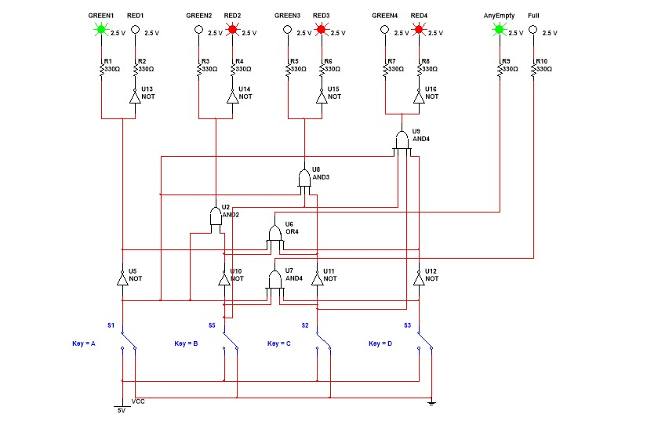
Full:
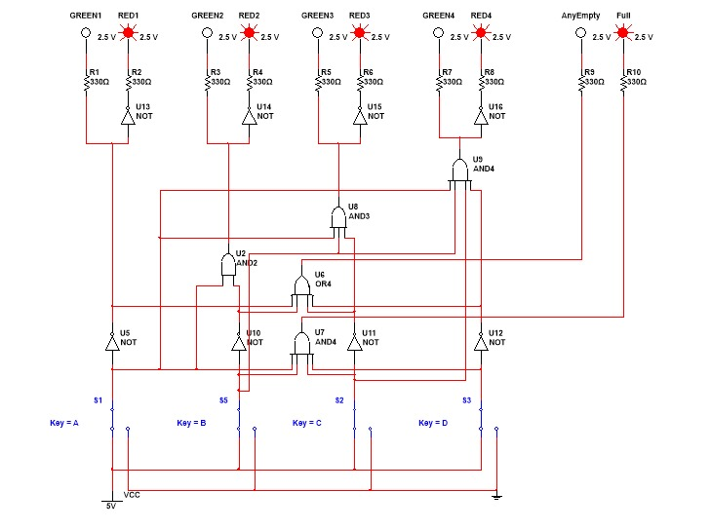
Priority Parking Slot Truth Table :
Slot1 | Slot2 | Slot3 | Slot4 | Green1 | Green2 | Green3 | Green4 | Red1 | Red2 | Red3 | Red4 | AnyEmpty | Full
0 | 0 | 0 | 0 | 1 | 0 | 0 | 0 | 0 | 1 | 1 | 1 | 1 | 0
0 | 0 | 0 | 1 | 1 | 0 | 0 | 0 | 0 | 1 | 1 | 1 | 1 | 0
0 | 0 | 1 | 0 | 1 | 0 | 0 | 0 | 0 | 1 | 1 | 1 | 1 | 0
0 | 0 | 1 | 1 | 1 | 0 | 0 | 0 | 0 | 1 | 1 | 1 | 1 | 0
0 | 1 | 0 | 0 | 1 | 0 | 0 | 0 | 0 | 1 | 1 | 1 | 1 | 0
0 | 1 | 0 | 1 | 1 | 0 | 0 | 0 | 0 | 1 | 1 | 1 | 1 | 0
0 | 1 | 1 | 0 | 1 | 0 | 0 | 0 | 0 | 1 | 1 | 1 | 1 | 0
0 | 1 | 1 | 1 | 1 | 0 | 0 | 0 | 0 | 1 | 1 | 1 | 1 | 0
1 | 0 | 0 | 0 | 0 | 1 | 0 | 0 | 1 | 0 | 1 | 1 | 1 | 0
1 | 0 | 0 | 1 | 0 | 1 | 0 | 0 | 1 | 0 | 1 | 1 | 1 | 0
1 | 0 | 1 | 0 | 0 | 1 | 0 | 0 | 1 | 0 | 1 | 1 | 1 | 0
1 | 0 | 1 | 1 | 0 | 1 | 0 | 0 | 1 | 0 | 1 | 1 | 1 | 0
1 | 1 | 0 | 0 | 0 | 0 | 1 | 0 | 1 | 1 | 0 | 1 | 1 | 0
1 | 1 | 0 | 1 | 0 | 0 | 1 | 0 | 1 | 1 | 0 | 1 | 1 | 0
1 | 1 | 1 | 0 | 0 | 0 | 0 | 1 | 1 | 1 | 1 | 0 | 1 | 0
1 | 1 | 1 | 1 | 0 | 0 | 0 | 0 | 1 | 1 | 1 | 1 | 0 | 1

Simulation:
Simulation was performed in Multisim. By toggling each SPDT switch, correct behavior of individual slot indicators, AnyEmpty, Full, and encoded outputs was verified.

Conclusion:
The Parking Slot Availability Indicator was successfully designed and simulated. The system accurately detects parking availability and provides clear visual and encoded outputs. This design is simple, efficient, and can be extended for larger parking systems.

References:
- Digital Logic Design Morris Mano
- Multisim User Documentation
- Lecture Notes CALD Course

